Steven Im, Ruben Hinojosa Torres, Taicheng Song

University of colorado Boulder

APPM 2360

Matrix transformations

**Image Translation**

Images are made up of matrices in an ordered triple that gives it both orientation and color. Our purposes particularly line up with processing grayscale images so that we only must deal with light intensity. As such, just as we can alter and manipulate matrices, we can do the same with images in MATLAB.

In our first example of image processing, we alter the photo given to us, *photo1.jpg*, by raising the exposure through the values of the pixel intensity. There are several ways to do this. In particular, you can raise the value of every pixel uniformly by a single value or you could also scale the value of the pixels by a number. The differences that these methods produce is one method produces a higher contrast image (scalar multiplication) while the other preserves it (addition). Nonetheless, both raise the exposure in their own ways. For our purposes, we uniformly raised the value of every pixel by a number within the matrix. The results are as follows:



**Figure 5.1.1** for MATLAB code used to generate increased exposure image.

Now, when given a 4 by 4 matrix “A” where we would want to switch the left most column with the right most column, we would swap those columns in the identity matrix “E”, and multiply the matrices as AE to get the swapped result. This is unsurprising as the result of the identity matrix is going to reflect how the image is going to look like exactly after we multiply the matrix through. However, this result only works in the form AE as you will not be able to preserve the columns values when multiplying through as EA. Multiplying the matrix in this way results in the top and bottom rows being swapped. The matrix E is as follows alongside an example of its transformation:



$$E= \left[\begin{matrix}0 & 0 & 0 & 1 \\ 0 & 1 & 0 & 0 \\ 0 & 0 & 1 & 0 \\ 1 & 0 & 0 & 0\end{matrix}\right]$$

**Figure 5.1.2** for MATLAB code used to generate matrix transformation

Now, in order to shift an image by 140 pixels horizontally, we can take the same matrix given to us in Section 3 of image manipulation, set r to 140, and instead of multiplying T before the shifted identity matrix, we multiply after to get a horizontal shift of 140 pixels. Since the identity matrix “E” alters our matrix “T”, we replace the number first r rows of T, with the last of E, then replace the rest of T with the first part of E. We take this transformed matrix and multiply through with the image. This subsequently results in the following image of *photo1.jpg*:

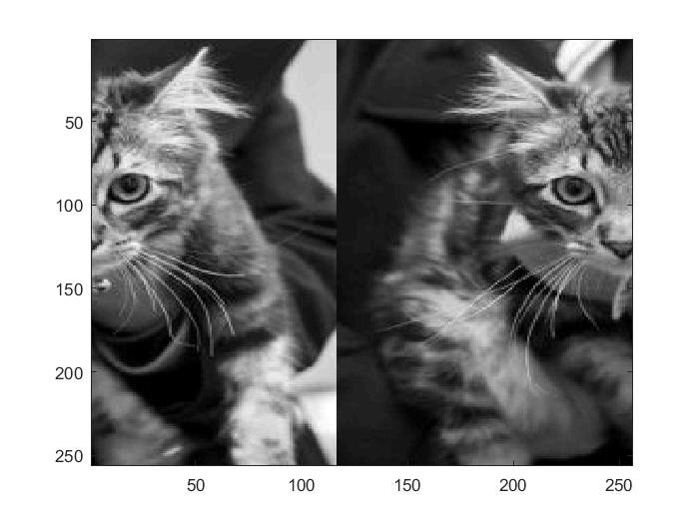

The identity matrix and the transformed matrix is as follows:

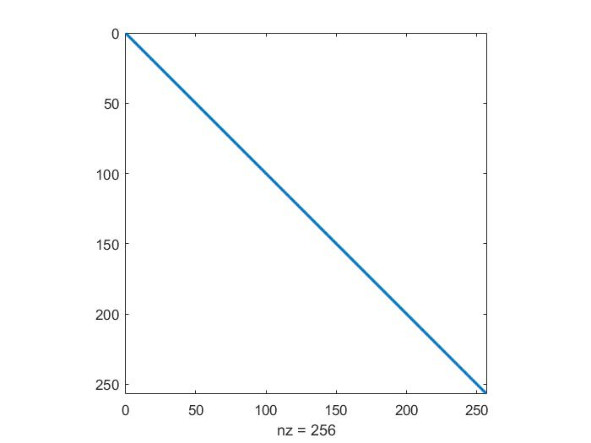 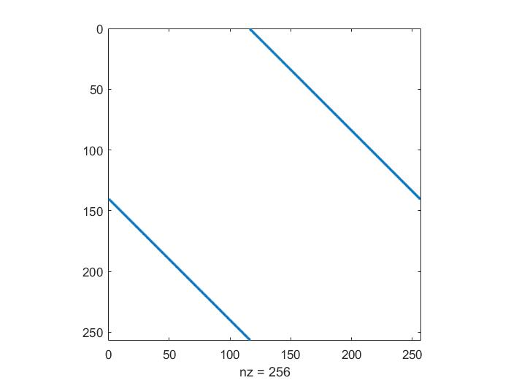

**Figure 5.1.3** for MATLAB code to produce shifted image and the matrix transformation.

As you can see in the figure above on the right, the identity matrix is shifted at 140 pixels nears the 150 mark on the y-axis.

To perform both a horizontal shift of 140 pixels and a vertical shift of 100 pixels, we can just repeat the process as performed in the previous problem but with a vertical shift. This vertical shift is in addition to the horizontal shift from before but with the pixel, “r”, being changed to 100, and multiplying the transformed matrix before the image in the form EA where E is the transformed matrix and A is the image itself. This results in the image being shifted both 100 pixels vertically on top of the already horizontally shifted image of 140 pixels. The resulting image transformation is as follows:

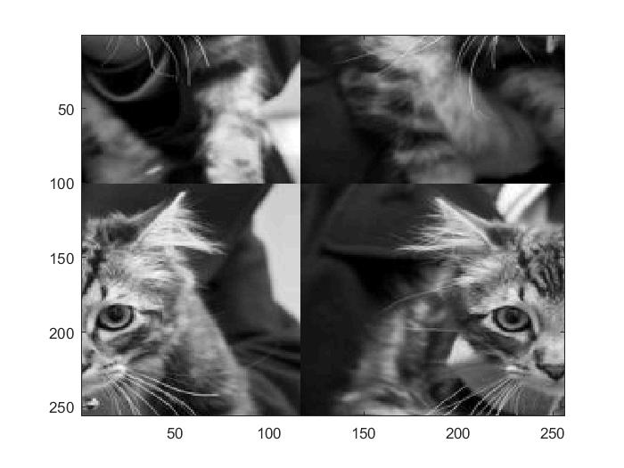

The matrices used for the first horizontal shift and the vertical shift is as follows respectively:

 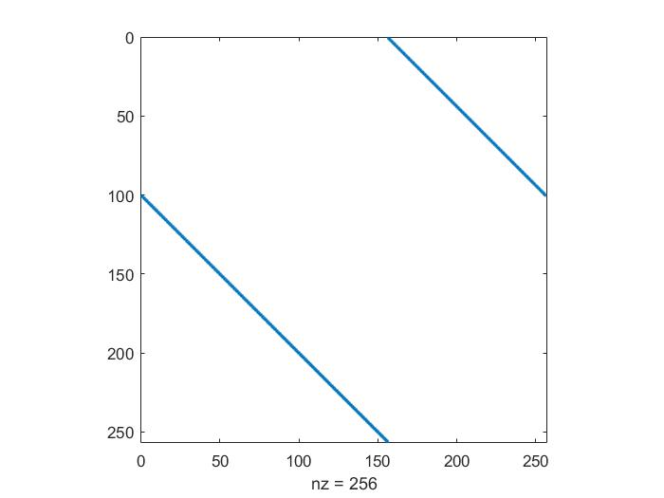

**Figure 5.1.4** for MATLAB code used to produce the images above.

To flip an image upside down, we are going to have to change rearrange every value of the identity matrix to flip an image upside down. This matrix happens to be the identity matrix but flipped upside down. This makes sense as every row is swapped with its corresponding row half way through the identity matrix. The flipped image is as follows:

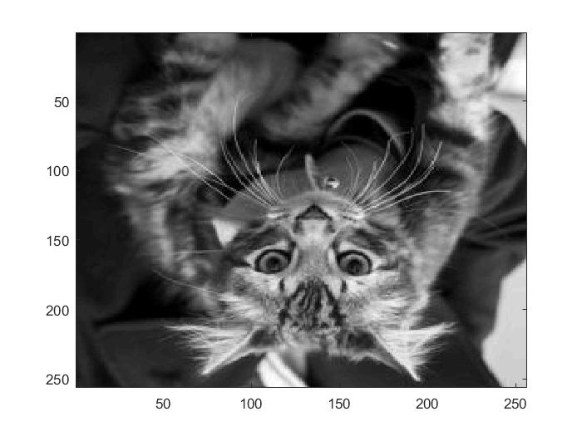

The transformed identity matrix to produce this image is as follows:

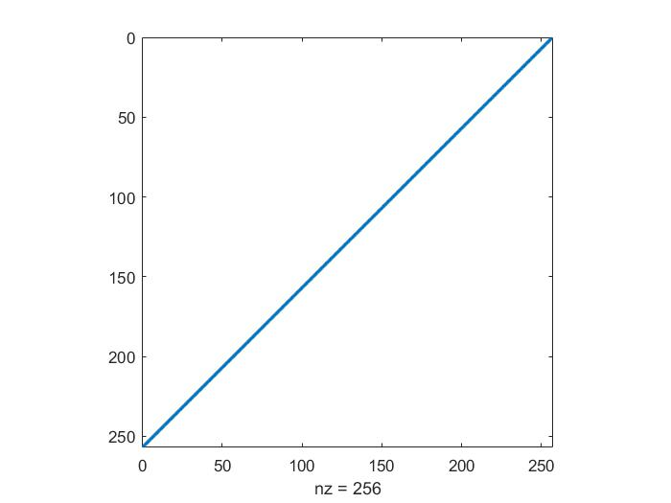

**Figure 5.1.5** for MATLAB code to produce upside down image

**Image Compression with Discrete Cosine Transform**

The DCT matrix, “C”, is a matrix transformation that alters another’s data in a matrix according to its frequencies. Due to this ability to alter certain types of frequencies, we have the benefit to particularly discard higher frequencies within images that our eyes don’t notice to preserve space for our memory. The DCT matrix has the unique property that it is its own transpose and inverse. This gives us major flexibility in transforming and deconstructing our 2-D matrices.

Due to its unique property that that DCT matrix C = C-1, we can prove that C2 is the identity matrix for a 5 by 5 matrix. We simply implement the DCT formula given to us for a 5 by 5 matrix, and loop twice for the row and column components. Then, we take our C and square it to give us our 5 by 5 identity matrix. The result is as follows:



**Figure 5.2.1** for MATLAB code for identity proof for DCT matrix C.

When we dive deeper into the properties of the DCT matrix, we discover some unique things about the matrix C. In particular, when looking at values n = 2, 3, and 4, we see that their determinants are all the same. Specifically, the determinant is always -1. Due to its ability that it is its own transpose and inverse, this shows that its inverse always exists. Therefore, the matrix has full rank and always produces a unique solution. (**Figure 5.2.2** for determinant proof).

Additionally, we can observe the matrix’s eigenvalues and observe its relationship with the determinant. We know that the determinant is always -1 so when we take the product of the diagonal elements of the matrix, we can expect that the eigenvalues will either be 1 or -1. This number will be determined on the size of the square matrix as it correlates to -1 being multiplied by itself over and over again due to the determinant. And as such, the results are correct with the plot in a complex plane for $n=512$ is as follows:



**Figure 5.2.3** for MATLAB code to produce image and proof.

As explained before, the pattern alternates between 1 and -1 for the eigenvalues as the product of diagonal elements will produce this change since the determinant is -1. This makes sense since C-1 is invertible and can be row reduced to echelon form to the identity matrix. Thus, the only solution to $A\overline{v}= λ\overline{v}$ for $λ$ is only 1 or -1. It Should be noted that the eigen values do not have an imaginary part, they change between 1 and -1, this extremely small number is due to the rounding within MATLAB.

Now, in order to undo a 2-D DCT, we would have to take the DCT of twice of both X, the image matrix, into Y and of Y, the undone matrix. This is because C2 = I, so we can just undo this process with the same process since it is the inverse of itself. Thus: C2 = I. So, I*A = A. If Y = C*X*C, we can undo this with X = C*Y*C which is equal to I*X*I. This returns it back to X = X. (**Figure 5.2.4** for further proof and visualization.)

We now have enough information to practice some compression on our images. To do this, we perform the 2-D discrete cosine transformation to turn our image into a data of frequencies. Next, we choose a value “p” that will be used to determine the amount of the frequencies/data will be zeroed out. A value of p = 0 means none of the image is save and a value of p = 1 means no compression. For our purposes, we chose p = 0.1, p =0.3, and p = 0.6 to demonstrate how compression is seen at a wide range of p values. The following are displayed respectively:

 



$p=0.1$ $p=0.3$

$p=0.6$

**Figure 5.2.5** for MATLAB code for compression

As you can see in the above images, the compression for p = 0.1 has the most noticeable compression with all of the image subsequently being “smoothed out” and distorted. However, this has the least amount of memory held due to the amount of zeroing that took place. With p = 0.3 and beyond, the compression is not very noticeable, if at all with most of the image being preserved fairly well due to a right balance of high frequencies being discarded but with the right amount of lower frequencies to see no difference in the image. This however does not produce a file as small as the p = 0.1 file. But at some point, you have to think about how much data your sacrificing for image quality.

From the previous value before, the value p becomes fairly small before we sacrifice much of the quality in the image. This may be due to the amount of higher frequencies and garbage that the image holds that we can’t even see which results in a large amount of compression we can undergo before noticing a difference in the image. An image with especially great detail and contrast will most definitely take up lots of storage due to the amount of detail it has to process for image. Thus, it could be that too much space is taken up for extra detail being stored in the image, which is why we can compress to such a small value of p. From our own experiences with compression, we can see that a value of p = 0.27 produces a fairly balanced image that doesn’t sacrifice too much in image quality. The results are as follows:



**Figure 5.2.6** for MATLAB code to produce $p=0.27$ compression image.

Our compression ratio is defined as the nonzero uncompressed elements over the nonzero compressed elements. For our values, p = 0.1, p = 0.3, and p = 0.5, we have the following compression ratios:

|  |  |
| --- | --- |
| P values | Compression Ratio |
| P = 0.1 | 50.3911 |
| P = 0.3 | 5.5782 |
| P = 0.5 | 2.0022 |

**Figure 5.2.7** for MATLAB code for compression ratio values

As per the table above, you can see that the ratio grows quite radically when jumping to smaller p values. While a higher p values, the ratio becomes very little in comparison.

Now, we can use this method of compression to reduce the noise of an image to a certain degree. For this, we can run the compression matrix for different values of p to see which values produce a better image. And from our values of p through trial and error, we see a fairly “saved” image between p = 0.2 and p = 0.22. It gets rid of those higher frequencies that the noise gets created from but still saves the image fairly well to a degree where image is still distinguishable. This method is very similar to how noise is reduced in an image with for example, a high ISO noise. Our image is as follows for p = 0.21:



**Figure 5.2.8** for MATLAB code when $p=0.21$ for compression.

Overall, the image looks fairly good with little noise that can be seem from the image. Looking at different values of p at 0.1, 0.2, and 0.3, we can see that the file size produced it 11KB, 11KB, and 24KB respectively. If minimum loss in image quality is desired then this p is approximately 0.21, where anything greater or equal to 0.22 produces an increase in storage use.

**Appendix**

**Figure 5.1.1**

%Pulling The Image.

x = imread('photo1.jpg');

x_gray = double(x);

%Set desired brightness.

brightness = 160;

%Create second image for comparison.

%Increase in brightness, which is just the addition

%of certain number to each element of the matrix.

x_gray2(:,:,1) = x_gray(:,:,1) + 255*brightness/255;

%Plotting.

subplot(1,2,1);

imshow(x_gray,[0,255]);

subplot(1,2,2);

imshow(x_gray2,[0,255]);

**Figure 5.1.2**

%Create Matrix

A = zeros(4,4);

%Replace with visual values.

A(:,2) = 63;

A(:,3) = 126;

A(:,4) = 189;

%In order to replace 1st and last column.

%We use a combination of the examples given.

E = [0,0,0,1;

0,1,0,0;

0,0,1,0;

1,0,0,0];

%Matrix operation for new image.

Z = A * E;

%Visual Representaion.

subplot(1,2,1);

imshow(A,[0,255]);

subplot(1,2,2);

imshow(Z,[0,255]);

**Figure 5.1.3**

X = imread('photo1.jpg')

X_double = double(X);

% process image

[m,n] = size(X);

r = 140;

E = eye(m);

T = zeros(m);

% fill in the first r rows of T with the last r rows of E

T(1:r,:) = E(m-(r-1):m,:);

% fill in the rest of T with the first part of E

T(r+1:m,:) = E(1:m-r,:);

X_shift = X_double*T;

% multiply through after the image to perform horizontal shift

imagesc(uint8(X_shift));

colormap('gray');

spy(T, 13);

% transformed matrix

**Figure 5.1.4**

X = imread('photo1.jpg');

X_double = double(X);

[m,n] = size(X);

r = 140;

E = eye(m);

T1 = zeros(m);

% fill in the first r rows of T with the last r rows of E

T1(1:r,:) = E(m-(r-1):m,:);

% fill in the rest of T with the first part of E

T1(r+1:m,:) = E(1:m-r,:);

X_shift1 = X_double*T1;

% performs the horizontal shift

r = 100;

T2 = zeros(m);

% fill in the first r rows of T with the last r rows of E

T2(1:r,:) = E(m-(r-1):m,:);

% fill in the rest of T with the first part of E

T2(r+1:m,:) = E(1:m-r,:);

X_shift2 = T2*X_shift1;

% performs the vertical shift

imagesc(uint8(X_shift2));

colormap('gray');

spy(T2, 13);

spy(T1, 13);

**Figure 5.1.5**

X = imread('photo1.jpg');

X_double = double(X);

% process image

[m,n] = size(X);

E = flip(eye(m));

% flips the identity upside down

X_shift1 = E*X_double;

% multiply the matrix to the image

imagesc(uint8(X_shift1));

colormap('gray');

spy(E, 14);

% transformed matrix

**Figure 5.2.1**

%Concatenating

C = zeros(5,5);

for i = 1:5

for j = 1:5

C(i,j) = sqrt(2/5)*cos(pi*(i-(1/2))*(j-(1/2))/5);

end

end

%spy(C);

%Verify C = C^-1 by verifying C * C = I5

I = C * C;

%Need to round because matlab doesn't automatically.

I = round(I);

spy(I);

**Figure 5.2.2**

%For n = 2.

n = 2;

C2 = zeros(n,n);

for i = 1:n

for j = 1:n

C2(i,j) = sqrt(2/n)*cos(pi*(i-(1/2))*(j-(1/2))/n);

end

end

%For n = 3.

n = 3;

C3 = zeros(n,n);

for i = 1:n

for j = 1:n

C3(i,j) = sqrt(2/n)*cos(pi*(i-(1/2))*(j-(1/2))/n);

end

end

%For n = 4.

n = 4;

C4 = zeros(n,n);

for i = 1:n

for j = 1:n

C4(i,j) = sqrt(2/n)*cos(pi*(i-(1/2))*(j-(1/2))/n);

end

end

% %Visualization.

% subplot(2,2,1);

% spy(C2);

% subplot(2,2,2);

% spy(C3);

% subplot(2,2,3);

% spy(C4);

%Determinants

C2_determinant = round(det(C2));

C3_determinant = round(det(C3));

C4_determinant = round(det(C4));

display(C2_determinant);

display(C3_determinant);

display(C3_determinant);

%Determinants are always -1

%Therefore C^-1 always exists.

**Figure 5.2.3**

%For n = 512.

n = 512;

C512 = zeros(n,n);

for i = 1:n

for j = 1:n

C512(i,j) = sqrt(2/n)*cos(pi*(i-(1/2))*(j-(1/2))/n);

end

end

% Eigen Values.

Eig_Values = eig(C512);

% Eigen Values result in either +-1 +- 0i

%Which simplifies to 1 or -1

plot(Eig_Values','*');

**Figure 5.2.4**

%C^2 = I, or C * C = I, and since IA = A Then

%Y = CXC, to undo this X = CYC, CYC = IXI, X = X

%Pull The image and making it double.

X = double(imread('boulder.jpg'));

n = 901; %Since image is 901x901

C = zeros(n,n);

for i = 1:n

for j = 1:n

C(i,j) = sqrt(2/n)*cos(pi*(i-(1/2))*(j-(1/2))/n);

end

end

%Transform is

Y = C * X * C;

Y = C * Y * C;

% Z = X. then

imshow(Y,[0,255]);

%True

**Figure 5.2.5**

%Reading the image

X = double(imread('boulder.jpg'));

n = 901; %Since image is 901X901

C = zeros(n,n);

for i = 1:n

for j = 1:n

C(i,j) = sqrt(2/n)*cos(pi*(i-(1/2))*(j-(1/2))/n);

end

end

%Transform is

Y = C * X * C;

p = 0.1;

% p = 0.3 and p = 0.6 repeated as well

% when p = 0, none of the matrix is saved , p=1 means no compression

for i = 1:n

for j = 1:n

if i + j > p*2* n

Y(i,j) = 0;

end

end

end

Y = C * Y * C;

imshow(Y,[0,255]);

**Figure 5.2.6**

%Reading the image

X = double(imread('boulder.jpg'));

n = 901; %Since image is 901X901

C = zeros(n,n);

for i = 1:n

for j = 1:n

C(i,j) = sqrt(2/n)*cos(pi*(i-(1/2))*(j-(1/2))/n);

end

end

%Transform is

Y = C * X * C;

nonzero_uncompressed = nnz(Y);

p = 0.27;

% when p = 0, none of the matrix is saved , p=1 means no compression

for i = 1:n

for j = 1:n

if i + j > p*2* n

Y(i,j) = 0;

end

end

end

nonzero_compressed = nnz(Y);

display(nonzero_uncompressed);

display(nonzero_compressed);

Y = C * Y * C;

imshow(Y,[0,255]);

%Like the question states it's really up to preference

%For me this is close to a correct balance.

**Figure 5.2.7**

%Reading the image

X = double(imread('boulder.jpg'));

n = 901; %Since image is 901X901

C = zeros(n,n);

for i = 1:n

for j = 1:n

C(i,j) = sqrt(2/n)*cos(pi*(i-(1/2))*(j-(1/2))/n);

end

end

%Transform is

Y = C * X * C;

nonzero_uncompressed = nnz(Y);

p = 0.1; % change for p = 0.3 and p = 0.5

% when p = 0, none of the matrix is saved , p=1 means no compression

for i = 1:n

for j = 1:n

if i + j > p*2* n

Y(i,j) = 0;

end

end

end

nonzero_compressed = nnz(Y);

CR_p = (nonzero_uncompressed)/(nonzero_compressed);

display(CR_p);

**Figure 5.2.8**

%Reading the image

X = double(imread('boulder_noisy.jpg'));

n = 901; %Since image is 901X901

C = zeros(n,n);

for i = 1:n

for j = 1:n

C(i,j) = sqrt(2/n)*cos(pi*(i-(1/2))*(j-(1/2))/n);

end

end

%Transform is

Y = C * X * C;

nonzero_uncompressed = nnz(Y);

p = 0.21;

% when p = 0, none of the matrix is saved , p=1 means no compression

for i = 1:n

for j = 1:n

if i + j > p*2* n

Y(i,j) = 0;

end

end

end

nonzero_compressed = nnz(Y);

CR_p_Var = (nonzero_uncompressed)/(nonzero_compressed);

display(CR_p_Var);

Y = C * Y * C;

imshow(Y,[0,255]);

imwrite(Y,'DCT_prob8.jpg');

%When P = 0.1 the file is 11KB

%When P = 0.2 the file is 11KB

%When P = 0.3 the file is 24KB

%Barrier is between P = 0.21 and P = 0.22

%At this point the weight begins to increase

%From 11KB also, Image quality seems to be ok.